

FORM

SMARTRACK® SUBSCRIPTION AND DEPLOYMENT

AUTHORISATION

Summary
To activate SmarTrack® systems, complete and email this form to RCT’s servicing branch: support@rct-global.com (for all regions).
Note
Devices cannot be configured or viewed on the customer site until activation has been completed.

Contact Information
Contact Name: | Name of person authorising this form / subscription.
Company Name: | Company that the authorising person is employed by.
Date: | Date
Email Address: | Email address of the authorising person.
Phone No: | Contact number of the authorising person.

Subscription Information
Subscription Part Number: | Refer to subscription part number reference table on page 2
Subscription Period: | Time in months. E.g. 12, 24, 36 etc.
Purchase Order Number: | Purchase order no. A copy of the order must be attached to this form.

Site Data
Equipment Supplier / OEM: | Company name as listed on the smartrackglobal.com website.
Company Name: | Your customer’s name as listed on the smartrackglobal.com website.
Site Name: | Your customer’s site name as listed on the smartrackglobal.com website.
Number of Machines: | Amount of machines being added to the site.

Serial Numbers (xxxxxx) (If applicable)
Note
Refer to Product Identification section for serial number location.

Subscription Part Number Reference
1 year | 2 year | 3 year | 4 year | 5 year
12131 | 12422 | 12423 | 12424 | 12130

Subscription Zone Map
- http://rct-global.com/Coverage

Product Identification
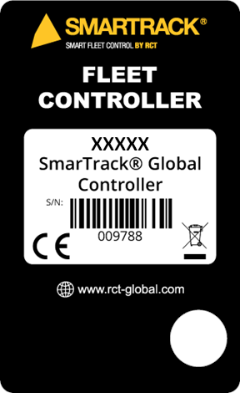
Product part number
Product description
Product serial number

About SmarTrack® Subscription
SmarTrack subscriptions are a critical component of after-sales OEM support to guarantee that software on-site remains compatible with RCT’s solutions’ release cycle. The incremental enhancements will be made based on the ongoing support of the SmarTrack system, and ensures features consistently deliver an efficient and reliable operation—this guarantees that clients receive the best overall benefit from their investment. RCT’s software and quality assurance teams are constantly innovating and improving our products as a result of continued improvement plans and direct market feedback.
Subscription benefits include the following:
- Access to a fully maintained and secure SmarTrack web portal which has regular product improvement features for the best user experience.
- Hosting and retention (backups) of data on secure cloud storage for the period of subscription.
- Delivery of SmarTrack email reports and alerts.
- Expert assistance on reports, structure, system configuration, and troubleshooting of the SmarTrack product by contacting our branch network or emailing support@rct-global.com.
- Over-the-air (OTA) firmware updates to all current production devices that include product improvement features, enhancements, and regular maintenance improvements.
- Regular reviews and audits to ensure worldwide best practice on data privacy, security, and encryption to meet minimum GDPR compliance.

Discover more: www.rct-global.com
AUSTRALIA:  +61 (0) 8 9353 6577 | AFRICA:  +27 (0) 83 292 4246 | CANADA:  +1 705 590 4001 | RUSSIA / CIS:  +7 (910) 411 11-74 | SOUTH AMERICA:  +56 9 5229 9409 | USA:  +1 801 938 9214

